Woojung Education and Culture Foundation | Scholarship Form
New Applicants

TO THE APPLICANT

- To apply for the scholarship please submit the scholarship form.

- As long as you meet the following requirements and have been recommended by your Embassy you are eligible to apply.

- A foreign student studying in Korea seeking financial support for tuition fee and living cost. (One must enroll formally at a university as an undergraduate or graduate student. Students enrolled in language classes do not qualify)

- Confirm that you do not exceed the term of the scholarship (The reference start date is the date you begin school)
- Undergraduate students in 4 year university : First 8 semesters (First 4 years)
- Master’s degree students : First 4 semesters (First 2 years)
- PhD degree students : First 6 semesters (First 3 years)
- Joint Master’s and PhD degree students : First 8 semesters (First 4 years)
Note : We are unable to offer scholarships beyond the noted terms.

- A student who has acquired over 80 points score (equivalent to a grade of B) of academic records. But if the student has financial difficulties, this shall also be considered.

Note : A student must have at least one semester of grades and as a full time student from a four year Korean university to apply for the scholarship. (In order to determine academic potential).

- A student with good manners.

- A student with no government scholarship. Students receiving no scholarships from any source will receive preferential consideration when selecting Woojung scholarship recipients.

IMPORTANT DEADLINES AND DATES

- Application submission date to Embassy Follow Embassy guidelines

  - Please submit you application to your Embassy promptly, at the designated deadline.
  - The foundation will in turn evaluate all applications on August 17, 2020.

- Scholarship Decision
The decision regarding the scholarship will be notified soon after.

- Scholarship Ceremony
During normal years all recipients must attend the biannual Scholarship Ceremony to receive the scholarship and certificate. But due to COVID-19, the 2020 fall ceremony is canceled once again. The certificates will instead be mailed to your home address.

Woojung Education and Culture Foundation | Scholarship Form

CHECKLIST OF REQUIRED FORMS
Please check boxes to ensure application is complete.
INCOMPLETE APPLICATIONS WILL NOT BE REVIEWED

NOTE : Please pay special attention to the self-introduction, study plan and recommendation.

- Application Form
(choose either English or Korean)

- Certificate of Admission

- Certificate of Enrollment (Original Copy)

- Transcript (Original Copy, most recently available)

- Recommendation letter by professor or dean
(choose either English or Korean)

- Self-Introduction (Succinct 1 page)

- Study Plan for 2nd semester of 2020 (Succinct 1 page)

- Copy of Bank Account with Account Number
(In order to wire the scholarship to recipients)

Woojung Education and Culture Foundation | Scholarship Application
2nd Semester 2020

Name |  | Last name |  |  |  | Gender
 |  | First name
Date of Birth |  | . . . | Nationality |  |  | Student ID
School |  |  | Major |  |  | GPA at last semester
Address in Korea |  | Please write address in Korean (We need complete Korean address to send certificate)
Native Country Address
E-mail  Must be gmail in order to use video conference capability |  |  | Mobile  (Korea) |  |  | Native country  Phone No.
Father |  | Name  (Native name)
 |  | Nationality
 |  | Job/Position
Mother |  | Name  (Native name)
 |  | Nationality
 |  | Job/Position
Bank |  |  | Account
Depositor |  |  | Relationship with  depositor | Father, Mother, Him / Her self
I am applying for the Woojung Education and Culture Foundation scholarship for the 2nd Semester of 2020.
I will return the scholarship award if I give up my studies during the semester or if I cannot complete the coursework without adequate reason. I confirm that the information given in this form is true, complete and accurate.
2020 . . .

Applicant : (signature)
Enclosure | 1. Application Form  3. Certificate of Admission  5. Transcript  7. Study Plan |  |  |  | 2. Recommendation Letter  4. Certificate of Enrollment  6. Self-Introduction  8. A Copy of Bank Book

우정교육문화재단 장학금 신청서
2020년도 제 2학기

성명 |  | 성 |  |  |  | 성별
 |  | 이름
생년월일 |  | . . . | 국적 |  |  | 학번 | . . .
학교 |  |  | 전공 |  |  | 직전학기  평점평균
한국 주소
모국 주소
이메일 Must be gmail in order to use video conference capability |  |  | 휴대폰번호  (한국) |  |  | 모국 연락처
부 |  | 성명  (원어 성명)
 |  | 국적
 |  | 직업/직책
모 |  | 성명  (원어 성명)
 |  | 국적
 |  | 직업/직책
은행 |  |  | 계좌번호
예금주 |  |  | 예금주와의 관계 | 부, 모, 본인
2020학년도 2학기 우정교육문화재단 장학금을 상기와 같이 신청하며, 만일 중도에 학업을 포기하거나
과정을 이수하지 못한 경우에는 수령한 장학금을 반환하겠습니다.

상기의 기재내용에 이상이 없음을 확인합니다.

2020 . . .
신 청 인 : (인 또는 서명)
첨부서류 | 1. 신청서 1부  3. 입학허가서 1부  5. 성적증명서 1부  7. 학업계획서 |  |  |  | 2. 추천서 1부  4. 재학증명서 1부  6. 자기소개서  8. 장학금 수령 통장 사본 1부
Certificate of Admissions (Sample)

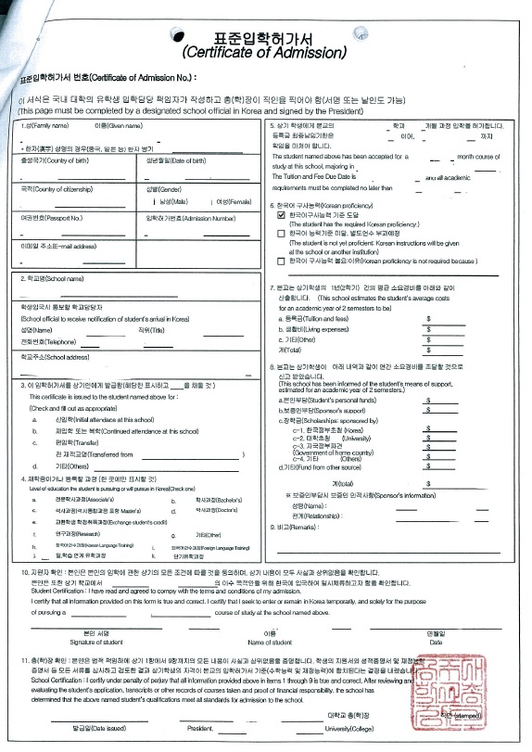

Certificate of Enrollment

Official Academic Record

Recommendation for Scholarship
Woojung Education & Culture Foundation

【 Student 】
Name :
Nationality : |  | Date of birth :
School : |  | Major :
【 Recommender 】
Name : |  | Tel :
Institution : |  | Position :
Recommendation :

※ Please provide your comments on recommendee's living condition, school attitude, personality, vision etc.
※ The recommender should be the one among professors, deans, or presidents, if it's from schools, or the someone
recommended by the organization that the Foundation approved.

I recommend the above student for scholarship of Woojung Education & Culture Foundation in 2nd Semester, 2020

. . .

Recommender : signature

우정교육문화재단 장학생추천서
【 학생 인적 사항 】
성 명
국적 및 생년월일 | 국 적 : 생년월일 :
소 속 | 학교명 : 학과(계열)명 :
【 추 천 인 란 】
성 명 |  | 연 락 처
소 속 |  | 직 위
추 천 내 용

※ 추천 대상자의 생활환경, 학업태도, 인성, 비전 등에 대해 추천인의 의견을 기재하여 주시기 바랍니다.
※ 대학교의 경우 지도교수, 학장, 총장 또는 기타 재단이사 2명 및 사회저명인사 추천.

위 학생을 2020년도 제 2학기 우정교육문화재단 장학생으로 추천합니다.

년 월 일

추천인 : (서명)

Self Introduction for 2nd Semester 2020

Study Plan for 2nd Semester 2020

